|  |  |  |  |
| --- | --- | --- | --- |
|  | Document Type: Spec Manual | REV.A | |
| Protection class:  INTERNAL ☐ RESTRICTED ☐ CONFIDENTIAL ☐ | | Pages: 1/5 |

|  |
| --- |
| DECOUPLEUR USER MANUAL  Decoupleur  Spec Manual |

|  |  |  |
| --- | --- | --- |
| Contract: | Project: |  |

|  |  |  |  |  |
| --- | --- | --- | --- | --- |
|  | **[PROTECTION CLASS]** | N° | | |
| Short Title | REV.A | PAGE: | 2/5 |

**APPROVAL**

|  |  |  |  |  |  |  |  |
| --- | --- | --- | --- | --- | --- | --- | --- |
| REV | DATE | Version | Author | Checker | Modifications observations | Status | Approver |
| A | 26/01/2021  23/03/2021 | 1.1 | Adrien DEBREUILLY & Nicola Bonichon |  |  | FIN |  |
|  |  |  |  |  |  |  |  |
|  |  |  |  |  |  |  |  |
|  |  |  |  |  |  |  |  |
|  |  |  |  |  |  |  |  |
|  |  |  |  |  |  |  |  |

**REVISIONS**

|  |  |  |  |
| --- | --- | --- | --- |
| Rev. | Status | Paragraph | Scope of the revision |
| A | FIN | All | First issue |
|  |  |  |  |
|  |  |  |  |

|  |  |  |  |  |
| --- | --- | --- | --- | --- |
|  | **[PROTECTION CLASS]** | N° | | |
| Short Title | REV.A | PAGE: | 2/5 |

**INTRODUCTION**

The purpose of this document is to define all the functionalities necessary for updating the Decoupler application. The list of functionalities and their constraints is exhaustive, and covers the functional needs of users. This document will serve as the basis for the technical design of the tool, the performance of functional tests as well as the assertion of the operational acceptance of the tool.

**TABLE OF CONTENTS**

1. INPUTS

1.1 Cable List

1.2 Global Path

1.3 Decoupling Room list

1.4 Decoupling Pattern list

2. OUTPUT

2.1 Files Output

2.2 File Name

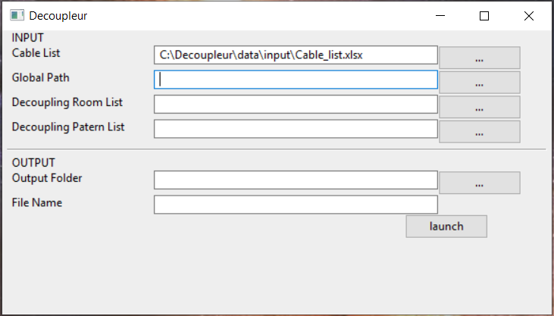

|  |  |  |  |  |
| --- | --- | --- | --- | --- |
|  | **[PROTECTION CLASS]** | N° | | |
| Short Title | REV.A | PAGE: | 4/5 |

1. Inputs
   1. Cable List:

* This first file input is this type excel with content of cable list
  1. Global Path:
* This second file input is this type excel with content of global path
  1. Decoupling Room list:
* This third file input is this type excel with the content of a room list
  1. Decoupling Pattern list:
* This fourth file input is this type csv with the content of pattern like example in the user manual

1. Output
   1. Files Output:

* This choice and the choice for destination of output file
  1. File Name:
* This choice and the name that the file will have